Configuring Oracle Linked Server

- Create a System DSN in the ODBC manager in Windows.
  - For this you were probably given a TNSNames.ora file to put locally on the server. This has the connection info the ODBC will use. If you have then you should see something in the TNS Service Name dropdown list.
  - The TNSNames.ora file is usually in c:\oracle\tnsadmin or somewhere close to that.
- In SSMS, connect to the server you want the linked server on and expand to Server Objects\Linked Servers\Providers
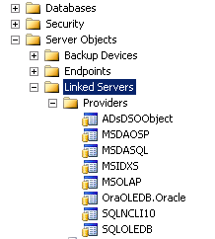
- Right-click on OraOLEDB.Oracle and go to properties.
- Check Allow inprocess.
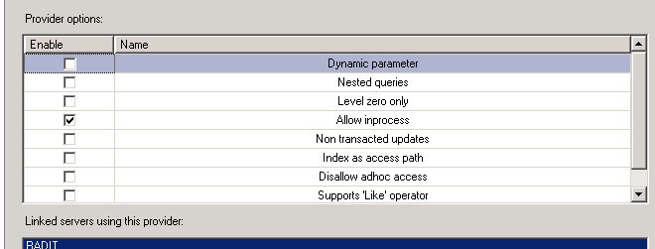
**This setting only effects new linked servers so if you’ve already got one setup, you’ll need to recreate it for it to pick up this setting.

- When creating a linked server to Oracle, never use the Microsoft Oracle client. It’s never worked. Use OleDB for Oracle.
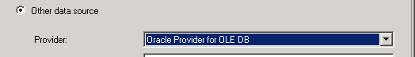
- Give the linked server a name. It doesn’t matter what you call it, but make it something descriptive.
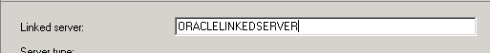

- For Data source, fill in the ODBC connection you created in Windows. This will be a System DSN, not a User DSN.

- On the Security tab enter in your username and password.
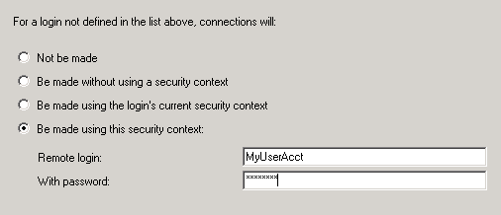
Test the connection:
select top (10) * from openquery(ORACLELINKEDSERVER, 'select * from MyTable')

