Fight Conference Harassment

About the Backup! Project at PASS Summit: Harassment happens at conferences. That sucks. It sure would be easier if you could have an insta-friend in a room of strangers. We should all be available to be that insta-friend: “Backup!”.

What to do?
- Get your Backup! ribbon, or make one yourself, or write “B!” on your hand.
- Ask someone for help if you’re harassed.
- Offer help if someone is harassed: “Cops, complaint, or company?” is a good place to start.
- Stay safe. Only do what makes you comfortable.

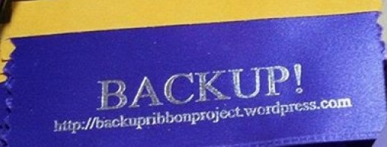

How to report harassment
- Please feel free to dial 911 if you want emergency services.
- And/or, connect with the duty officer: call or text 206.965.5950.
(You have a card in your badge holder with this number.)
- And/or, email governance@sqlpass.org with your report.
- And/or, you can submit a paper report at the info desk (anonymously, if you wish).

